**MESD LMS Documentation – Course Group Management for the Educator role**

**Purpose**

To allow educators to create and manage groups in their courses.

**Capabilities given to enable group management**

These capabilities were given to educators to allow them to create and manage groups in courses:

* “moodle/site:accessallgroups” to enable them to view content and user grades from groups they’re not part of. You can edit that if you do not wish for them to have access to all groups.
* “moodle/course:managegroups” provides the ability to add, edit, update or delete groups in a course.
* “moodle/course:viewhiddengroups” gives the ability to view all groups within a course regardless of visibility. This is needed to manage or oversee all groups within a course.

**Usage**

1. Log in using an **Educator** account.
2. Navigate to the course where you’d like to create a group.
3. Click on **Participants.**



1. Click on **Enroll Users**. A drop-down menu will open. Click **Groups** which is where you will create/manage groups.

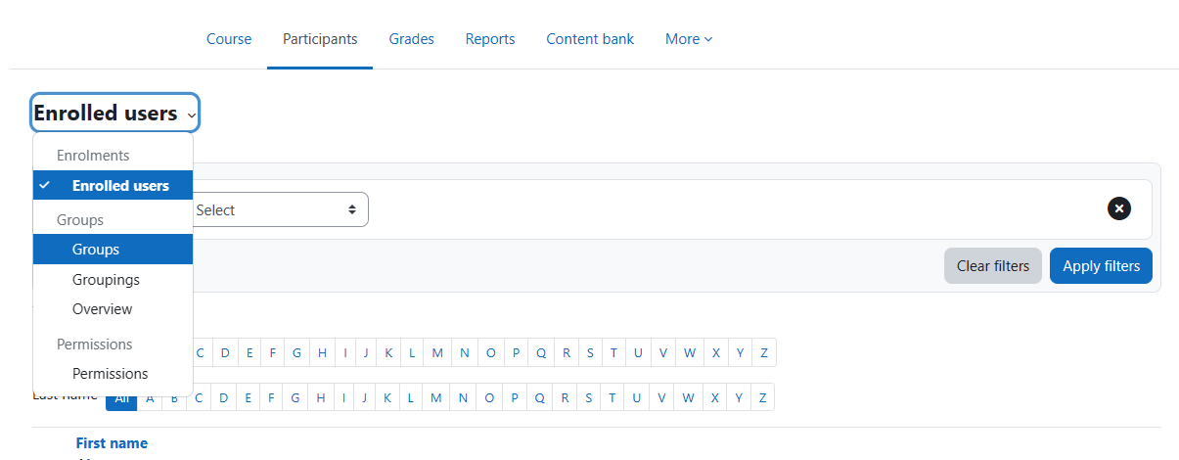

1. Scroll to the bottom of the page to **Manage**. Here you’ll have 3 options:
2. Create group.
3. Auto-create groups.
4. Import groups

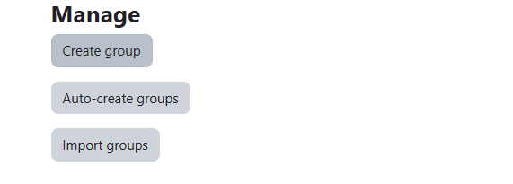

Click on **Create group** to create a group.

1. Fill in the group **General** settings and click save changes to create the group.
2. Add members to a group by going back to the **Group** page then selecting the group where you’d like to add members. Select **Add/remove users**.

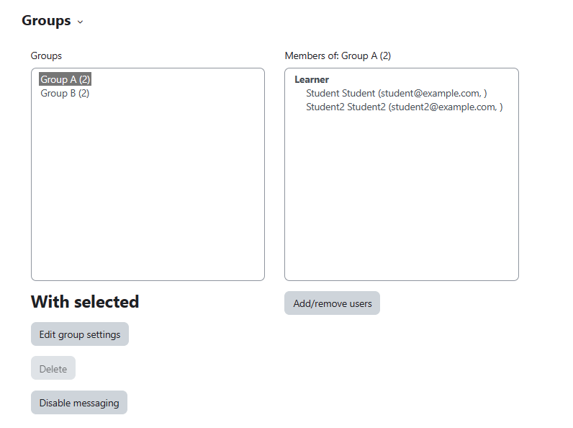

1. 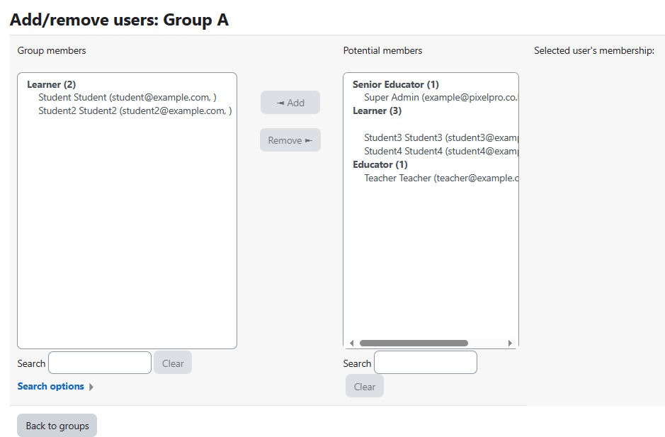From a list of potential members you can add/remover users in any way you see fit. These potential members are all the participants in a course.
2. Users have been added/removed from the group.

If you wish to edit group settings select a group from the **Groups** box. Below the is **With selected** where you can **Edit group settings** or **Disable messaging**.